**TASK 2: Install a web server (e.g., Apache or Nginx) on the EC2 instance**

**1. Install a web server (e.g., Apache or Nginx) on the EC2 instance**

**2. Check that any PC can access your Webpage.**

**3. Share your IP address.**

**Steps to install a web server (Apache) on the EC2 instance:**

1. Run the command **sudo yum install -y httpd** to install.

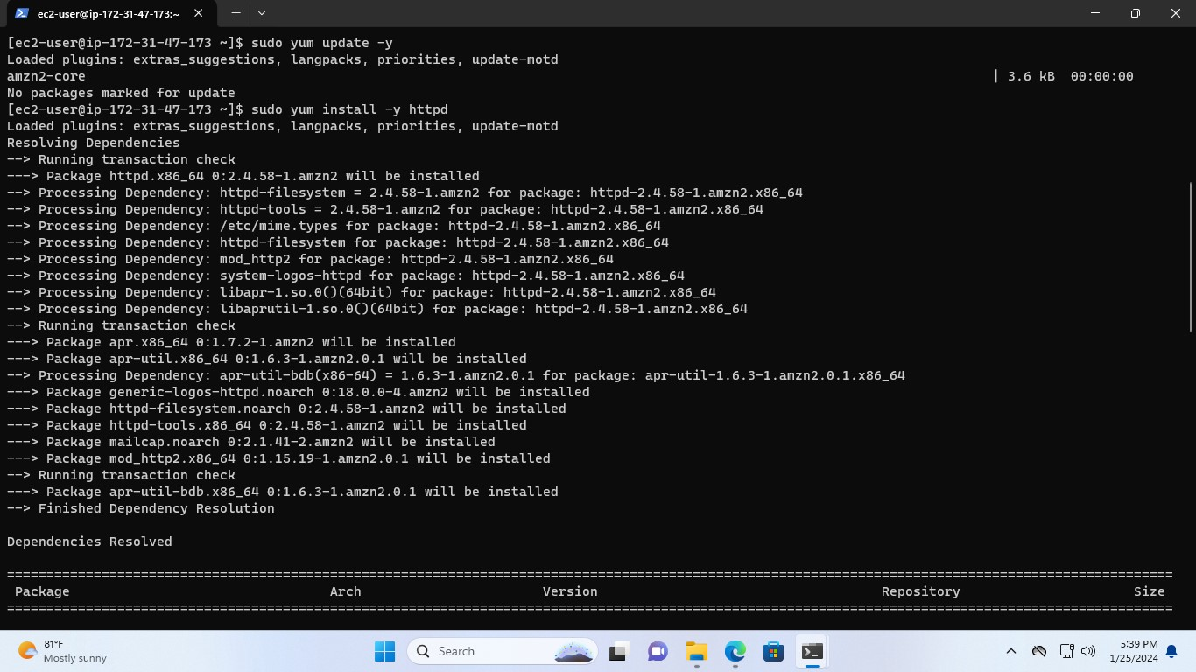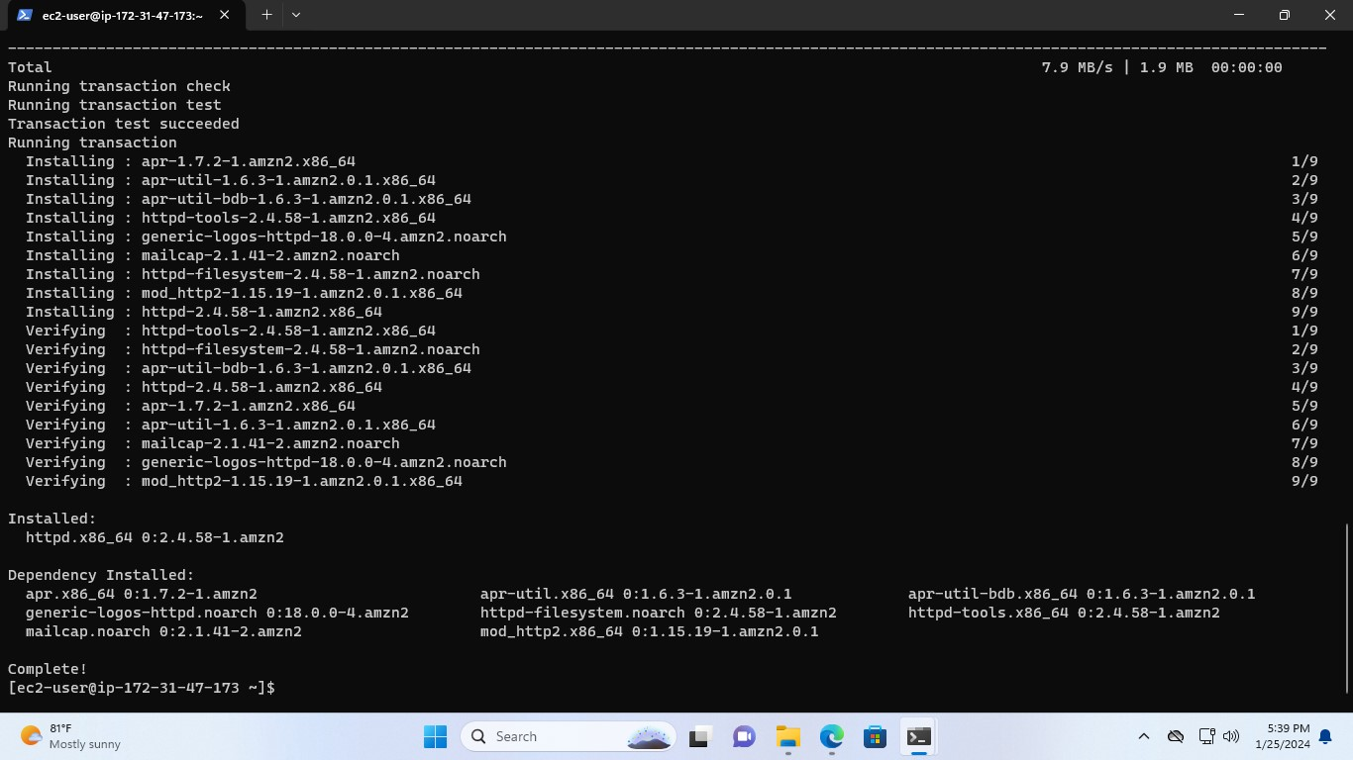

1. Now, start the server with **sudo systemctl start httpd** and enable it with the command **sudo systemctl enable httpd.**

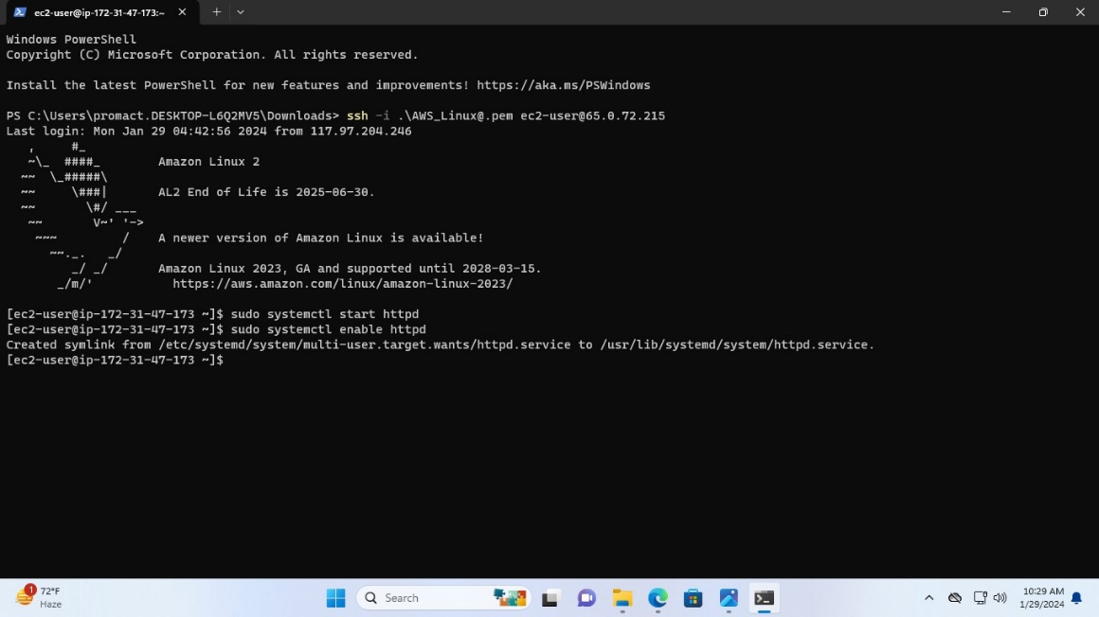

1. Check that the Apache server has started or not.

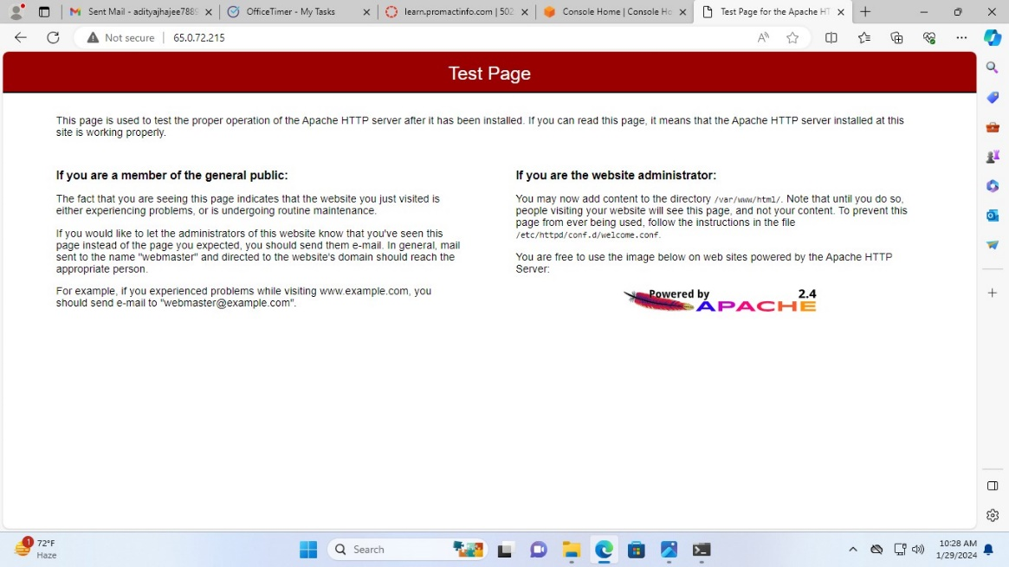

**Checking that any PC can access the Webpage:**

1. Run the command **sudo touch /var/www/html/index.html** to create the index.html file.

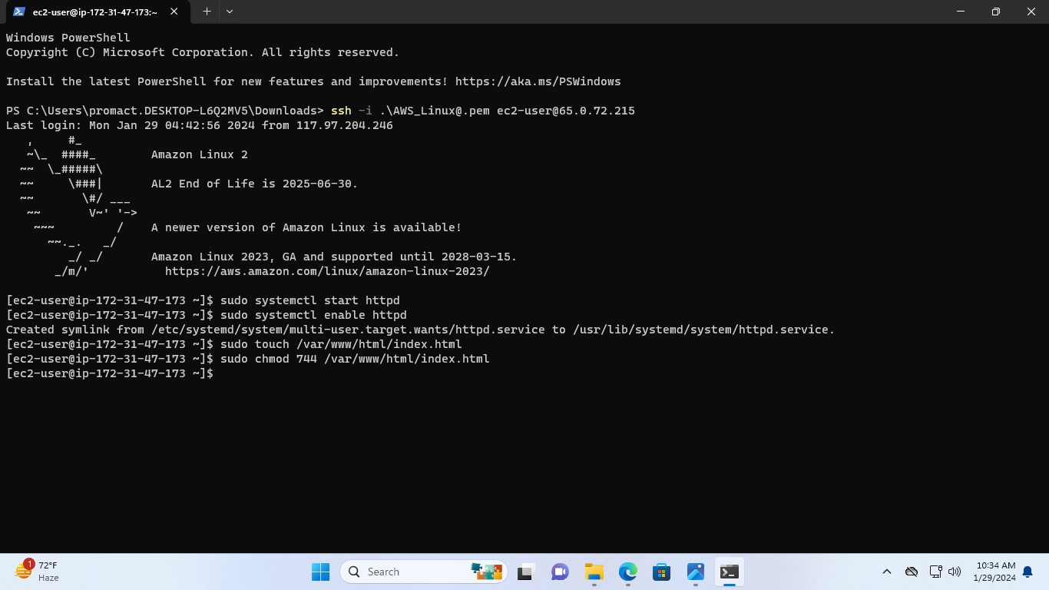

1. Run the command **sudo chmod 777 /var/www/html/index.html** to get the permission to read, write and execute.

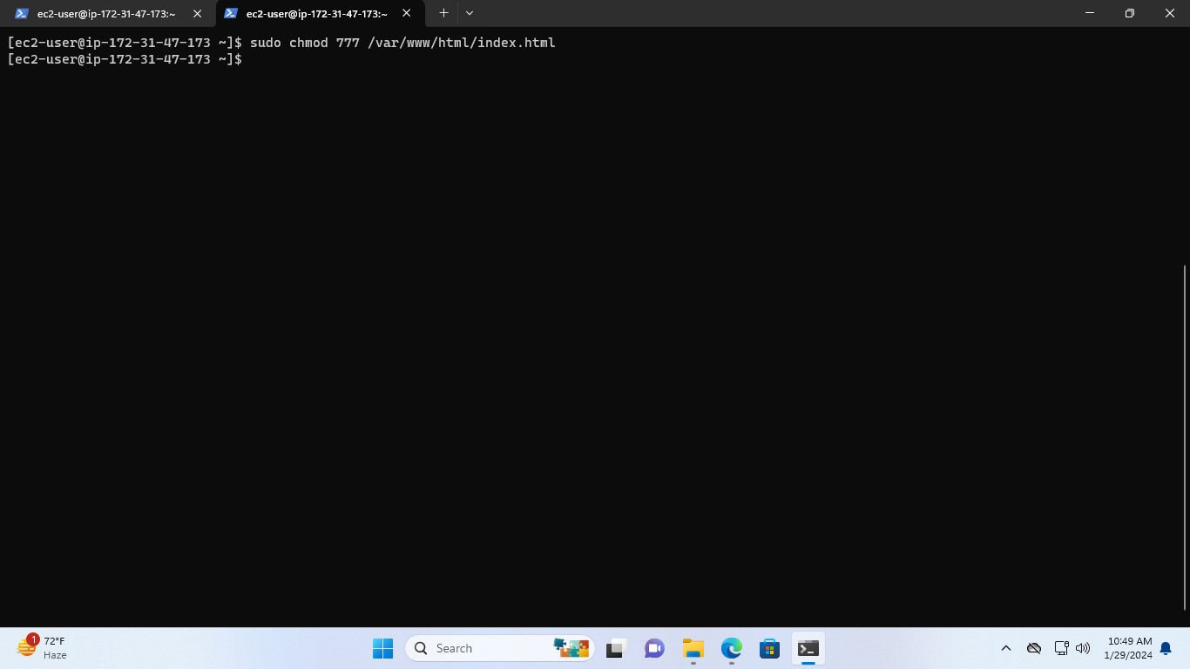

1. In order to add ip address in the index.html

First, run the command **echo ”<h1>IP ADDRESS: “ > /var/www/html/index.html**

Second, run the command **hostname -f >> /var/www/html/index.html**



Third, run the command **echo “</h1>” >> /var/www/html/index.html**



1. Testing the address 65.0.72.215

